May 10, 2024
Team Meeting

Jeff’s Corner: Sharing some "Big Rock" topics.

SUVA Updates: This morning SU Community will launch on FXL. This is advanced search/crawling.
Search/Crawling/Community-------SUVA/Chatbot-------- Live Chatting
Schedule Updates: International expanded support will go live next week. This will result in an expansion of Hours of Operations. Targeting Wednesday for a go-live… Phone system testing to be completed today.
Countries include Italy, Spain, France, Mexico, Chile and Argentina
PST | CST (+2hrs) | EST (+3hrs) | CLST (+3hrs) | ART (+4hrs) | CET (+9hrs) | AEDT ( Melbourne ) (+19hrs)
TJ- Mex | Guadalajara- Mex | Cancun-Mex
Calif staff | Texas staff | NC staff | Chile | Argentina Time | France, Germany, Spain, Italy | Australia corp and Rhey location
2:00 AM | 4:00 AM | 5:00 AM | 5:00 AM | 6:00 AM | 11:00 AM | 7:00 PM
3:00 AM | 5:00 AM | 6:00 AM | 6:00 AM | 7:00 AM | 12:00 PM | 8:00 PM
4:00 AM | 6:00 AM | 7:00 AM | 7:00 AM | 8:00 AM | 1:00 PM | 9:00 PM
5:00 AM | 7:00 AM | 8:00 AM | 8:00 AM | 9:00 AM | 2:00 PM | 10:00 PM
6:00 AM | 8:00 AM | 9:00 AM | 9:00 AM | 10:00 AM | 3:00 PM | 11:00 PM
7:00 AM | 9:00 AM | 10:00 AM | 10:00 AM | 11:00 AM | 4:00 PM | 12:00 AM
8:00 AM | 10:00 AM | 11:00 AM | 11:00 AM | 12:00 PM | 5:00 PM | 1:00 AM
9:00 AM | 11:00 AM | 12:00 PM | 12:00 PM | 1:00 PM | 6:00 PM | 2:00 AM
10:00 AM | 12:00 PM | 1:00 PM | 1:00 PM | 2:00 PM | 7:00 PM | 3:00 AM
11:00 AM | 1:00 PM | 2:00 PM | 2:00 PM | 3:00 PM | 8:00 PM | 4:00 AM
12:00 PM | 2:00 PM | 3:00 PM | 3:00 PM | 4:00 PM | 9:00 PM | 5:00 AM
1:00 PM | 3:00 PM | 4:00 PM | 4:00 PM | 5:00 PM | 10:00 PM | 6:00 AM
2:00PM | 4:00 PM | 5:00 PM | 5:00 PM | 6:00 PM | 11:00 PM | 7:00 AM
3:00 PM | 5:00 PM | 6:00 PM | 6:00 PM | 7:00 PM | 12:00 AM | 8:00 AM
4:00 PM | 6:00 PM | 7:00 PM | 7:00 PM | 8:00 PM | 1:00 AM | 9:00 AM
5:00 PM | 7:00 PM | 8:00 PM | 8:00 PM | 9:00 PM | 2:00 AM | 10:00 AM
6:00 PM | 8:00 PM | 9:00 PM | 9:00 PM | 10:00 PM | 3:00 AM | 11:00 AM
7:00 PM | 9:00 PM | 10:00 PM | 10:00 PM | 11:00 PM | 4:00 AM | 12:00 PM
8:00 PM | 10:00 PM | 11:00 PM | 11:00 PM | 12:00 AM | 5:00 AM | 1:00 PM
9:00 PM | 11:00 PM | 12:00 AM | 12:00 AM | 1:00 AM | 6:00 AM | 2:00 PM
10:00 PM | 12:00 AM | 1:00 AM | 1:00 AM | 2:00 AM | 7:00 AM | 3:00 PM
11:00 PM | 1:00 AM | 2:00 AM | 2:00 AM | 3:00 AM | 8:00 AM | 4:00 PM
12:00 PM | 2:00 AM | 3:00 AM | 3:00 AM | 4:00 AM | 9:00 AM | 5:00 PM
1:00 AM | 3:00 AM | 4:00 AM | 4:00 AM | 5:00 AM | 10:00 AM | 6:00 PM

Seasonal Saturday Schedule
Date | A Rep Name | B Rep Name | C Rep Name | D Rep Name
June 1,2024 | KV | JC |  | KP
June 8,2024 | KV | JC |  | KP
June 15,2024 | KV | JC |  | KP
June 22,2024 | KV | JC
June 29,2024 | KV | JC |  | KP
July 13,2024 | KV | JC |  | KP
July 20,2024 | KV | JC | BP | KP
July 27,2024 | KV | JC |  | KP
Aug 3,2024 | KV | JC | BP | KP
Aug 10,2024 | KV | JC |  | KP
Aug 17,2024 | KV | JC |  | KP
Aug 24,2024 | KV | JC | BP
Aug 31,2024 | KV | JC
NOTE: 6:30-11:00 work schedule PST.

High Season Priorities: During the high season we are often faced with competing priorities. Our number 1 priority is the phones. The majority of callers are irrigation and lighting professionals, and we need to serve them in a timely manner. OUR BUSIEST MONTHS ARE MAY AND JUNE……. Subject to weather conditions.
Start of your scheduled shift: Clock into Ultipro and immediately go available to the phone queue.
Breaks and Lunches: Breaks are 10 minutes and lunches can vary depending on the team member’s schedule. Quinten and I looked over the schedule to widen lunch overlap so those changes will be coming.
Project status: If you are called upon to take part in a project and you start prior to 7:30, please delay that work until our full staff is on at 7:30am. If during the day, Do not go on project status during lunch hours, we need all hands on deck for the scheduled gaps. 3-4pm is a good time to work on something since the Homeowner queue is off and we are only taking escalations from ROI
Shipping will be delayed: We will move to shipping 1 day a week only so that we are not taking Elvin off the phones too frequently, remember that customers need to return to their point of purchase, and we are only the exception to this rule.
Training: Training will be pushed to either non-phone hours or later in the season.
Lighting on the horizon for all level 1 technicians.

SALESFORCE:
PM Inquires: Friendly reminder to check for updates throughout the day. Important note, we can lean on each other for a second set of eyes as support to make sure we exhausted our internal resources prior submitting the inquiry.

Written communication turn around should be less than 48 hours with the exception of weekends.
New Macro: Written communication from Homeowners directed to ROI for content ROI can handle
Hydrawise BUT not admin stuff
Basic Irrigation
Email Template

Contact Us: ROI Call Center
Close
HTML Body
Thank you for contacting Hunter Technical Support.
Your question may be better answered over the phone as multiple emails may be required to answer your question(s) or solve the problem.
Please call our Technical Support Center at your earliest convenience.
- Dial 8007332823
- Press #1 for Homeowner
- Press #1 for Irrigation Support - You will then be connected to a live agent who will assist you.
Support Hours - Pacific Time Zone: 6:00 AM to 3:00 PM, Monday through Friday
Thank you again for contacting Hunter Technical Support.

ROI Performance:
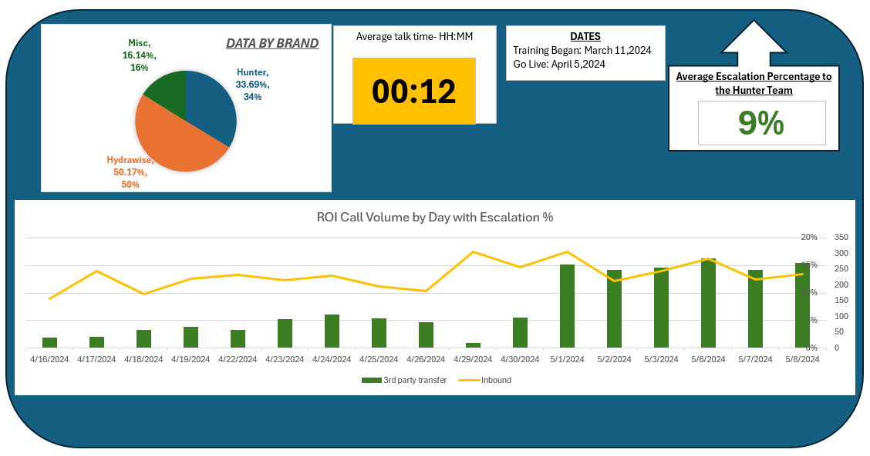

OPEN DISCUSSION

