April 5,2024 Team Meeting

# **AGENDA**

**CULTURE** Jeff Falk- Director of Marketing;

Talk about Central Irrigation marketing efforts.  They are our largest independent distributor. My goal is to share the culture of our customers.   Hunter's largest distributors are SiteOne, Ewing, Heritage, Horizon then Central. Check out this video if you don't know Central   <https://youtu.be/ZWT4AEVCybA?si=KgEuvUR_xgPn-uGQ>

**INTRODUCTIONS and PROMOTIONS**

This week we welcome Monica Richmond located in New York State and Dimitri Stevanus located in Pennsylvania to the Hunter Technical Support Team. Quinten has been promoted to Assistant Manager. Kathy has been promoted to Level 2 technician.

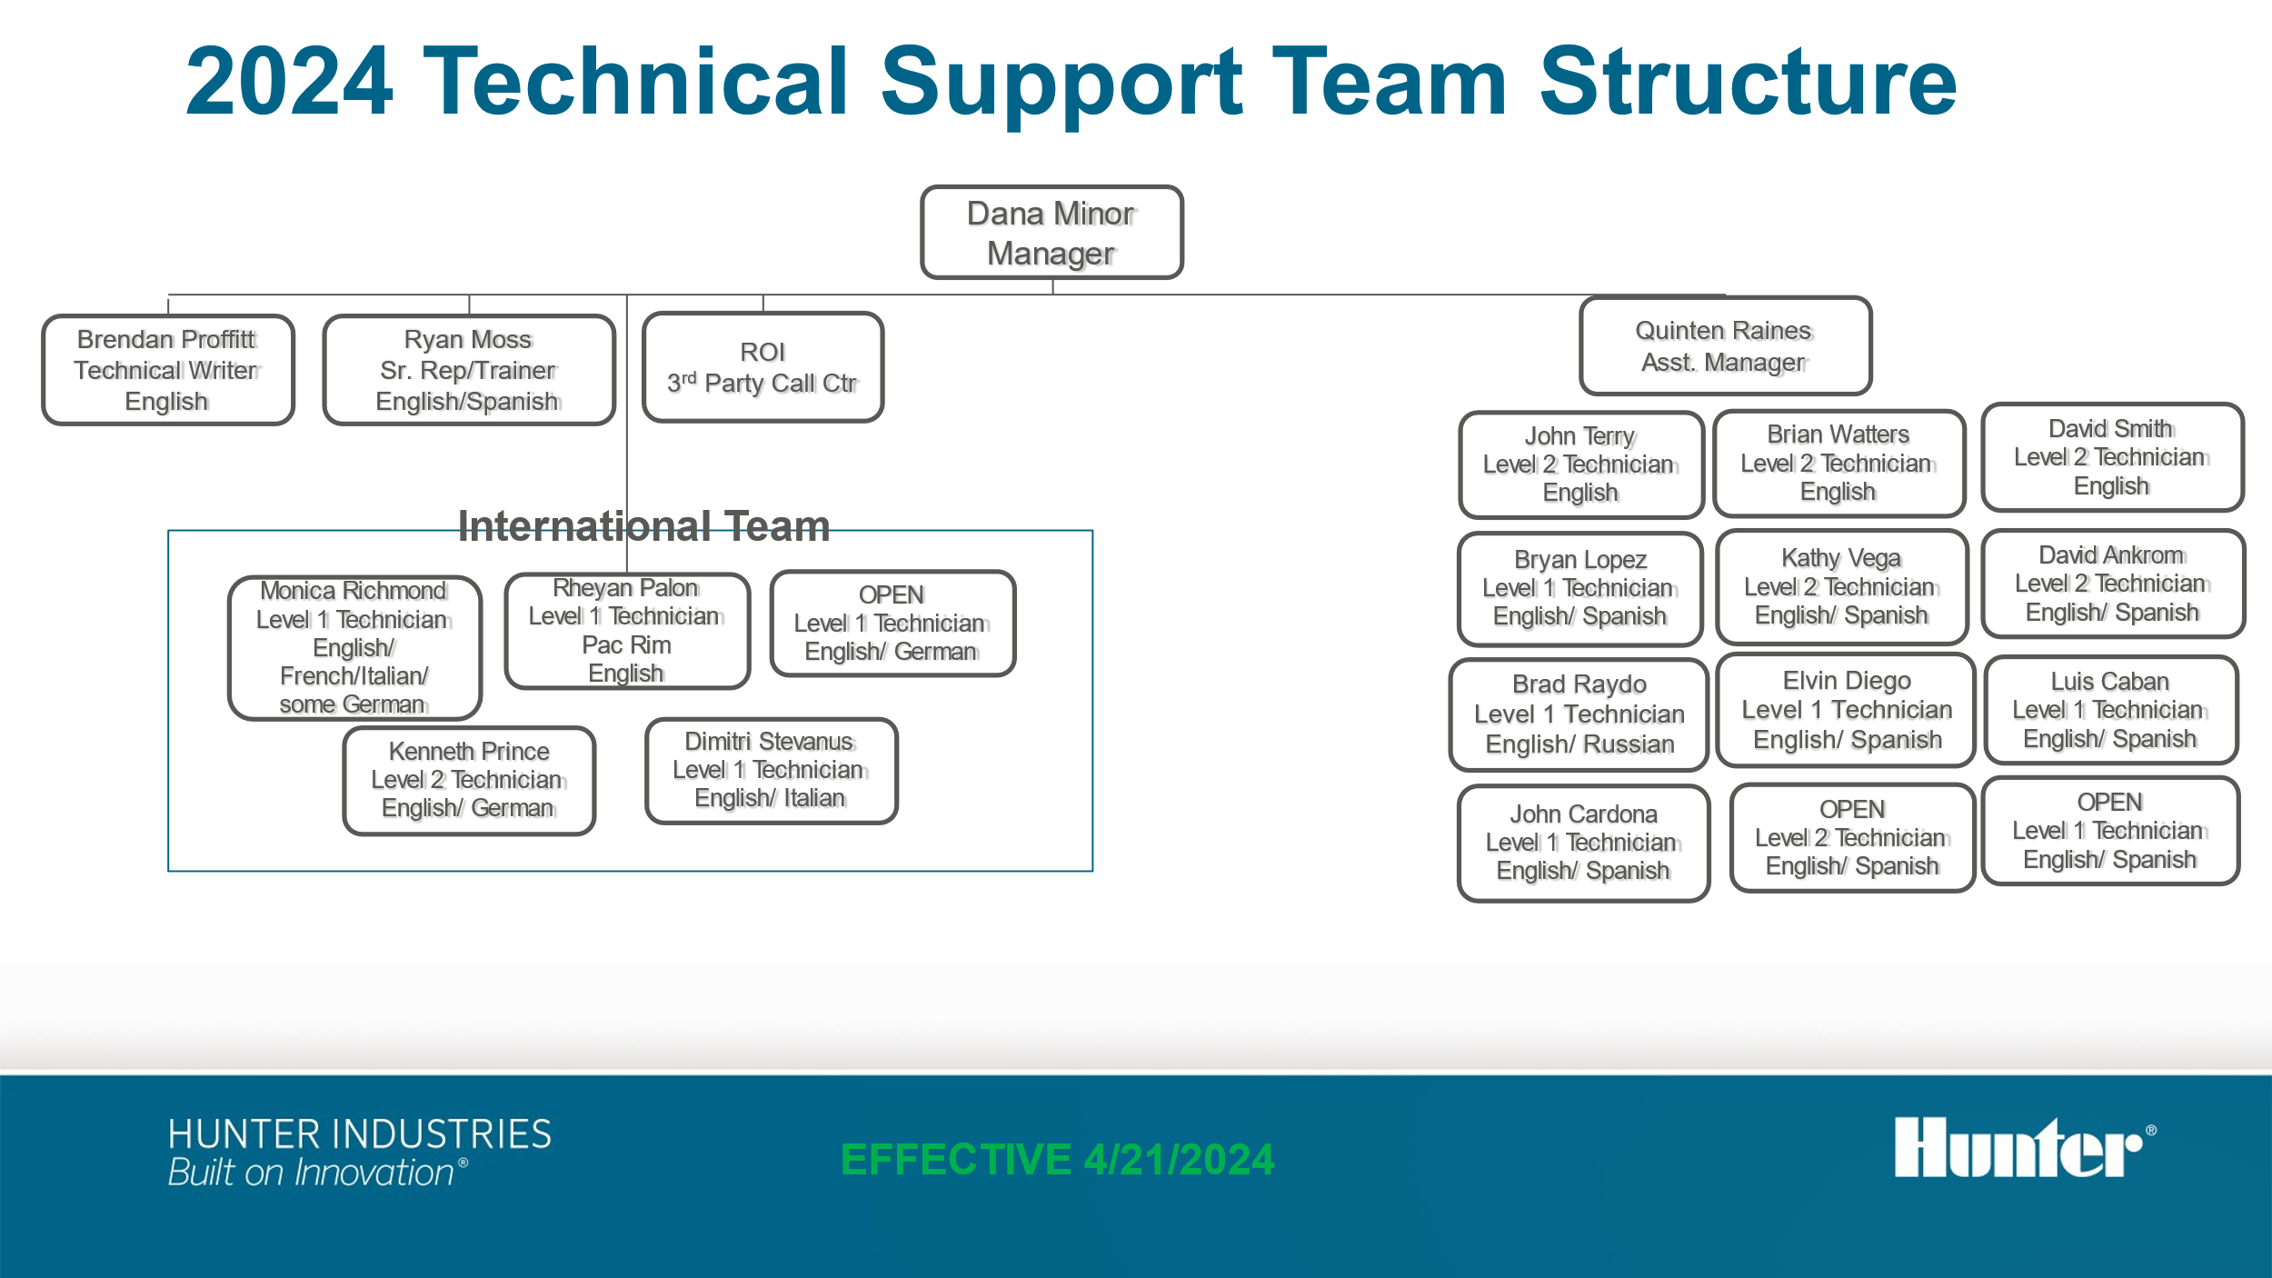

**LIVE TODAY**

ROI Team began taking calls this morning at 6am PST. 15 calls so far between 6 and 8am……Feedback??

**TRAINING**

**

**SEARCHUNIFY in Salesforce Case Module** by Jonathan Infante, Justin Uyan

|  |  |  |  |
| --- | --- | --- | --- |
| Challenge | System | Impact | Change |
| Technicians need to look at various locations for troubleshooting steps | SFDC | Technicians have to fill out the case separately from the TS steps. They will select the error code but then reach out to the team for the steps for troubleshooting | Provide within the case module the ability to search a KB and our Websites |

Step 1 Create our TS knowledge base in SSO Jan 26,2024

Step 2 Use SearchUnify to crawl all 3 Websites and KB within Salesforce Case 4/5/2024

